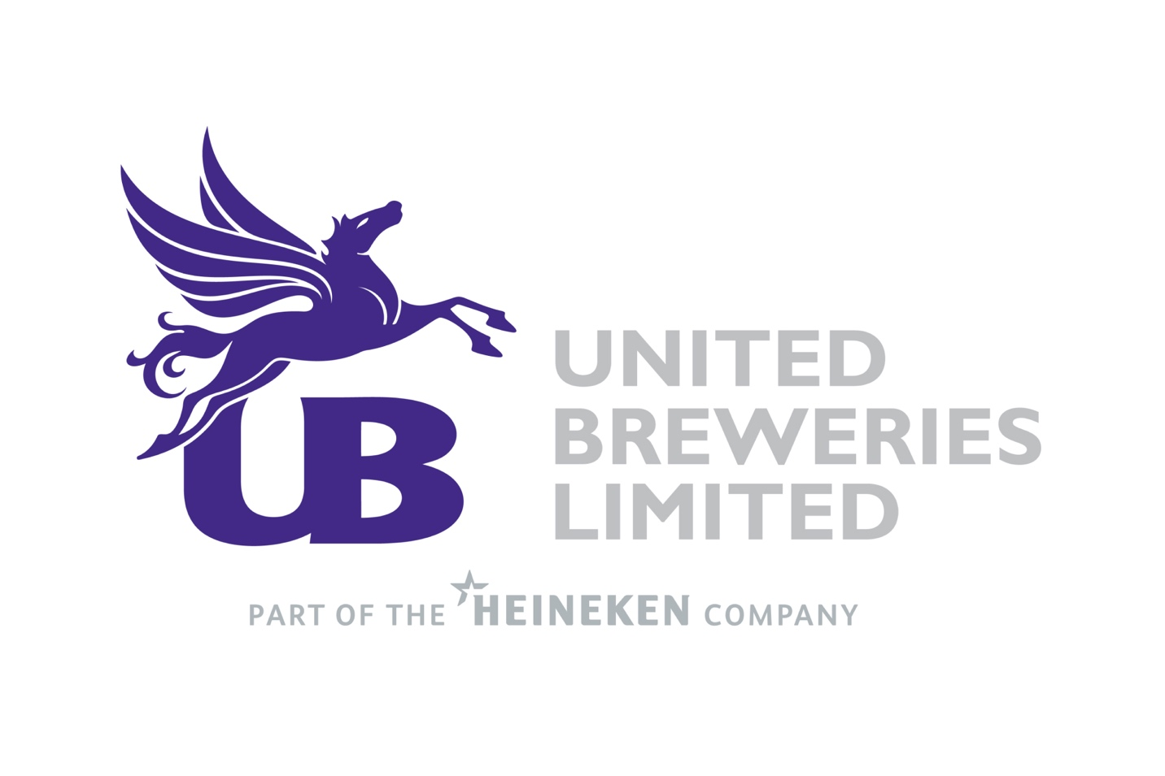

Equity Research Report
BY
Shubh Raaj Chopra

COMPANY OVERIEW
United Breweries Limited operates primarily in the manufacture, purchase and sale of beer, including licensing of brands, with a smaller non-alcoholic beverages segment. UBL's consolidated segment reporting identifies Beer and Non-alcoholic Beverages as its two operating segments. In FY2025, beer generated ₹19,40,326 lakh of segment revenue, while non-alcoholic beverages generated ₹528 lakh, demonstrating the overwhelming importance of the beer business to the group's revenue base.
UBL's business has a broad portfolio spanning mainstream and premium beer categories. The company's recent strategy has increasingly focused on premiumisation and innovation. FY2023 saw the launch of Heineken Silver in India, while FY2024 included products such as Queenfisher Premium, London Pilsner and Heineken Silver Draught Beer. The FY2025 report further highlights the expansion of the premium portfolio, including the launch of Amstel Grande in selected states.
The relationship with HEINEKEN is also relevant to the company's operating strategy. The FY2022 Annual Report identifies Heineken N.V. as the ultimate holding company effective July 29, 2021. UBL's annual reports repeatedly link its strategy to HEINEKEN's global capabilities, particularly in innovation, premium brands, sustainability and operational practices.

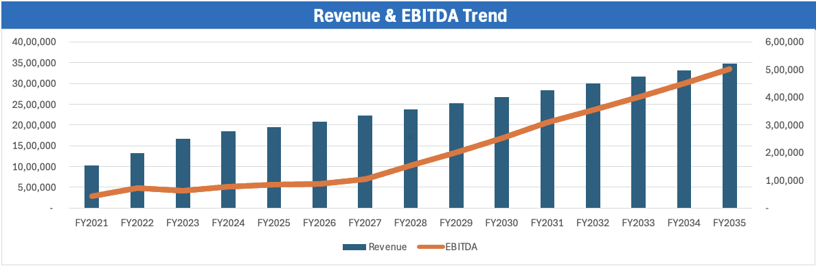
The company operates in an industry where revenue growth depends not only on underlying beer volumes but also on pricing, product mix and state-level market conditions. Because excise duties represent a substantial component of reported gross revenue, analysing the business solely on reported gross revenue can obscure the underlying operating economics. This distinction becomes important when interpreting margins and building the DCF.


BUSINESS MODEL
UBL's economic model can be viewed as a combination of volume growth, price realisation, premiumisation and operating leverage. Volume growth increases brewery utilisation and spreads fixed manufacturing and distribution costs over a larger revenue base. Pricing and premiumisation increase revenue per unit, while portfolio mix can improve profitability where higher-value products represent an increasing share of sales.
The FY2025 Annual Report provides direct evidence that premiumisation is becoming an important part of the company's growth model. Premium volume growth was close to 32% in FY2025, materially exceeding overall volume growth of 6%. The company attributes this momentum to localisation, portfolio choices, innovation and increased focus on the premium category.
The revenue model is also affected by state-level taxation and regulation. Beer pricing and distribution are subject to significant state-level differences, meaning that changes in state mix can influence both revenue realisation and margins. UBL itself identifies pricing approvals, state mix, regulatory developments and route-to-market changes as relevant factors in its operating performance.
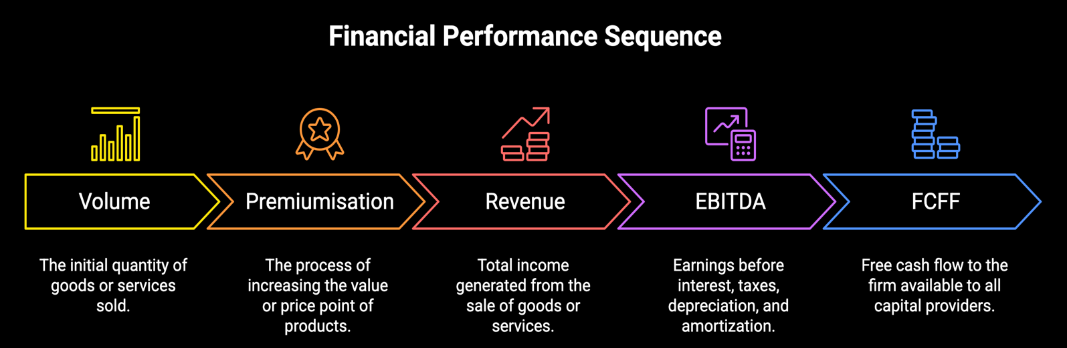
The company's cost structure includes raw materials, packaging, employee costs, manufacturing expenses, distribution, advertising and other operating expenses. Raw-material and packaging inflation had a particularly visible impact in FY2023, when UBL reported a gross-margin decline of approximately 700 basis points

The DCF therefore assumes that a combination of revenue growth and improving operating efficiency will translate into substantially stronger EBITDA and FCFF over the forecast period.

SHAREHOLDING PATTERN
The shareholding structure of United Breweries Limited is significantly promoter-led, with the Promoter & Promoter Group holding 70.83% of the company's total shares. Within the promoter group, foreign promoter ownership accounts for 61.52%, while Indian promoters hold 9.31%, indicating a predominantly foreign promoter ownership structure.
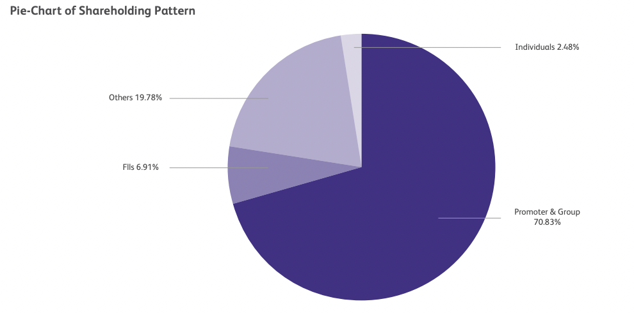
Foreign Institutional Investors (FIIs) hold 6.91% of the equity, while individuals account for 2.48%. The remaining 19.78% is held across other shareholder categories, with mutual funds representing the largest component at 15.00%.

Key Observations
Promoter & Promoter Group: 70.83%, representing the majority of the company's equity ownership.
Foreign Promoter: 61.52%, making it the largest individual shareholder category.
Mutual Funds: 15.00%, representing the largest non-promoter institutional holding.
FIIs: 6.91%, indicating meaningful foreign institutional participation.
Individuals: 2.48%, representing a relatively small portion of the total equity base.
Other shareholders: 4.78%, comprising categories such as IEPF, banks/financial institutions, governments, insurance companies, corporate bodies, trusts, NRIs and provident/pension funds.
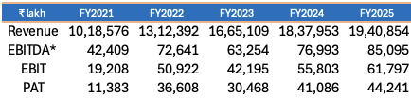
FINANCIAL PERFORMANCE

UBL's consolidated financial performance over FY2021–FY2025 demonstrates a clear recovery from the COVID-affected base.
The Annual Reports directly confirm the consolidated revenue and PAT figures. FY2021 revenue was ₹10,18,576 lakh and PAT was ₹11,383 lakh; FY2022 revenue increased to ₹13,12,392 lakh and PAT to ₹36,608 lakh. FY2023 revenue increased to ₹16,65,109 lakh, while FY2024 revenue increased further to ₹18,37,953 lakh. FY2025 revenue reached ₹19,40,854 lakh and PAT ₹44,241 lakh.
FY2022 represented a significant recovery year. Revenue increased by approximately 29% from FY2021, while PAT increased substantially as the business recovered from the pandemic disruption. FY2023 continued the volume recovery, with UBL reporting 31% volume growth and approximately 6% pricing, although raw-material and packaging inflation resulted in a substantial gross-margin decline.
FY2024 was more moderate. Volume growth was 1.8%, while premium volume increased close to 3%. The company reported an 8% increase in net sales, although the first quarter was affected by route-to-market changes and supply challenges.
FY2025 showed a stronger combination of volume and premium growth. Overall volumes increased 6%, premium volumes increased close to 32%, and net sales increased approximately 10%. The company also reported a 44-basis-point improvement in gross margin and a 35-basis-point improvement in EBIT.
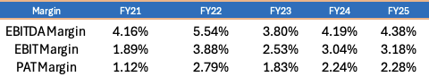
On the revenue convention used in the DCF model, EBITDA margin increased from 4.16% in FY2021 to 4.38% in FY2025, with considerable volatility during the period. EBITDA margin peaked at 5.54% in FY2022 before declining in FY2023 as input-cost pressures affected profitability.

FY2025 management commentary indicated improvement in gross margin and EBIT margin, supported by volume growth, pricing and premiumisation.
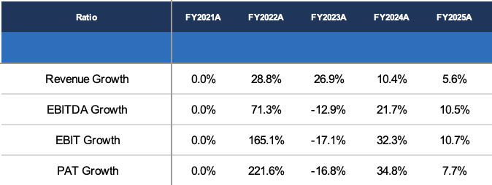

UBL's return ratios have improved alongside profitability. The FY2025 Annual Report reported ROE of 10.3% and ROCE of 13.0%, while FY2024 ROE was approximately 10.1%.
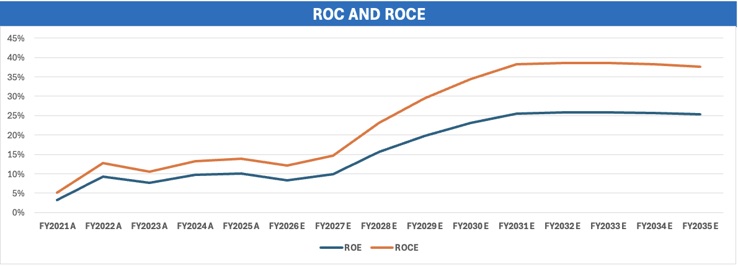
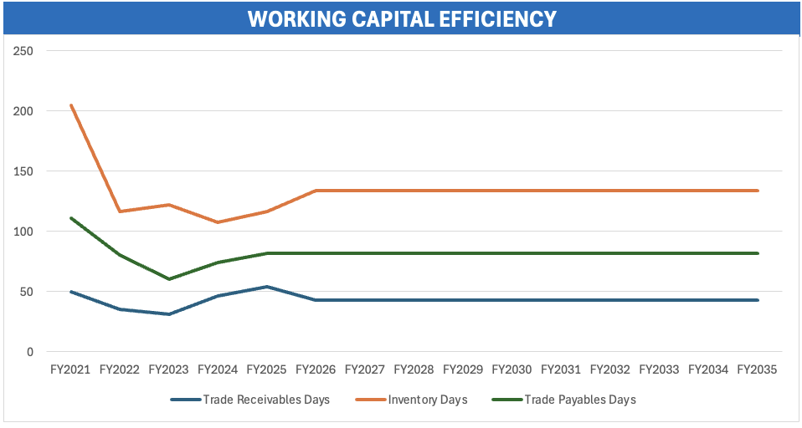
The working-capital ratios show greater volatility. Receivable days increased from 30.8 days in FY2023 to 53.8 days in FY2025, while inventory days increased from 107.7 to 116.4 days. The company attributed part of the receivable pressure to delayed collections from certain state government corporations

The DCF assumes a normalisation of working-capital requirements rather than carrying forward the FY2025 receivable position unchanged. Forecast assumptions are 43.1 receivable days, 133.5 inventory days and 81.5 payable days.
This is important because working-capital movements directly affect FCFF. The annual report's discussion of delayed collections and the company's use of working-capital demand loans and buyer's-credit facilities provides support for treating FY2025 working capital as an area requiring normalisation rather than assuming a simple continuation of the historical trend.
Historical CAPEX increased from ₹11,595 lakh in FY2023 to ₹23,200 lakh in FY2024 and ₹28,703 lakh in FY2025. Annual-report disclosures indicate CAPEX of approximately ₹156 crore, ₹190 crore and ₹254 crore respectively for these years.
The DCF forecasts CAPEX at approximately 1.33% of revenue, increasing from around ₹277 crore in FY2026E to approximately ₹463 crore by FY2035E. D&A is forecast at approximately 1.51% of revenue, reaching around ₹525 crore by FY2035E.
The announced ₹750 crore Uttar Pradesh brewery should therefore be specifically reconciled with the forecast CAPEX schedule before finalising the model.

DCF VALUATION
The valuation of United Breweries Limited is based on a Discounted Cash Flow (DCF) approach, where the company's future operating performance is translated into Free Cash Flow to the Firm (FCFF) and discounted to its present value using the Weighted Average Cost of Capital (WACC). The model forecasts the business from FY2026E to FY2035E, with revenue growth, operating margins, working capital, capital expenditure and depreciation forming the principal operating assumptions.
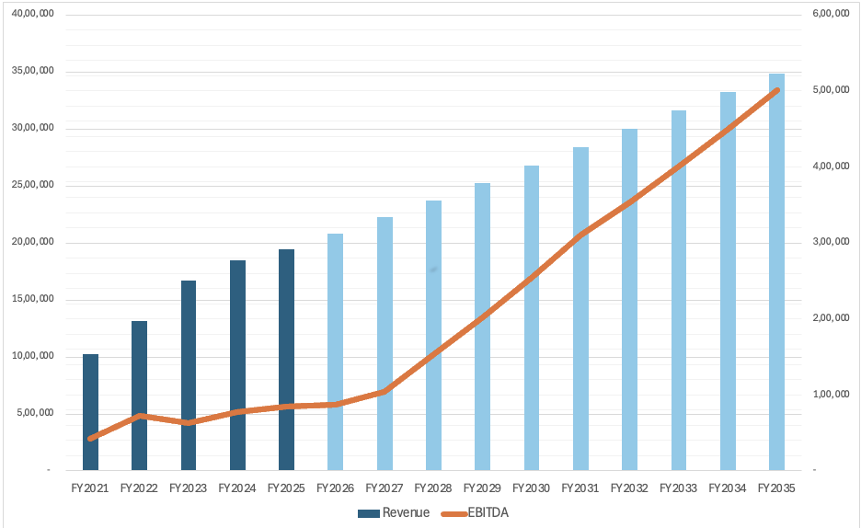
The model assumes revenue growth gradually moderates from 7.0% in FY2026E–FY2027E to 5.0% by FY2034E–FY2035E, resulting in revenue increasing from ₹19,40,854 lakh in FY2025 to approximately ₹34,75,001 lakh in FY2035E.
Figure 1: UBL Historical and Forecast Revenue
The forecast therefore represents a gradual normalisation of growth rather than an aggressive acceleration in revenue. The more significant change occurs at the operating-profit level. EBITDA increases from ₹85,095 lakh in FY2025 to ₹5,01,092 lakh by FY2035E, with EBITDA margin expanding from 4.38% to 14.42%.
The chart highlights the central feature of the DCF: revenue grows at approximately 6% CAGR, while EBITDA grows at approximately 19% CAGR over FY2025–FY2035. Consequently, the valuation is driven not only by topline growth but also by a substantial improvement in operating leverage. This margin expansion should therefore be treated as a key model assumption and sensitivity rather than a continuation of the historical margin trend.

Forecast FCFF
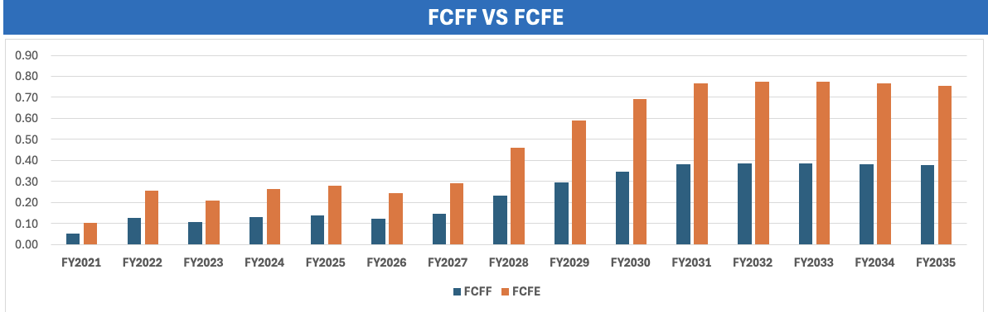
The forecast operating assumptions are converted into FCFF after considering EBIT, taxes, depreciation, capital expenditure and changes in working capital. Forecast FCFF increases from ₹59,940 lakh in FY2026E to ₹2,96,032 lakh by FY2035E.
Figure 3: Forecast FCFF Generation
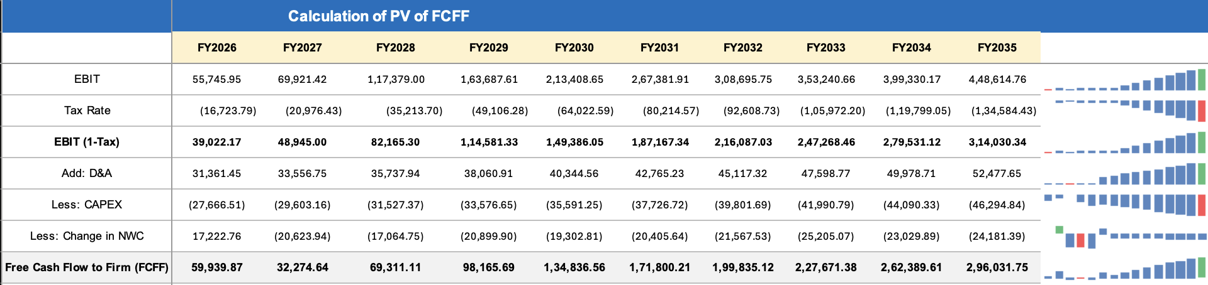
The FCFF profile reflects the increasing contribution of operating earnings as the forecast progresses. The relatively lower FCFF in FY2027E is followed by a sustained increase from FY2028E onward as EBITDA expands and the business generates progressively higher operating cash flows.
The increase in FCFF is particularly important because the DCF ultimately values the company based on these future cash flows rather than accounting earnings alone.
Key Observations:
- Historical FCFF Volatility: Negative in FY2023-25 due to massive NWC investment (receivables + inventory buildup post-COVID
- Forecast FCFF Inflection: FY2026E FCFF turns strongly positive (₹2,137 Cr) as NWC investment normalises and margins expand
- Steady-State FCFF Margin: ~11-12% of net revenue (FY2030+)
- FCFF CAGR (FY26-35): ~7.5% — driven by revenue growth + margin expansion + NWC normalisation
WACC and Discounting
The model applies a 12.8822% WACC to discount the forecast FCFF and terminal value to the valuation date. The WACC is predominantly equity-funded, with equity representing 98.08% of the capital structure and debt representing 1.92%.
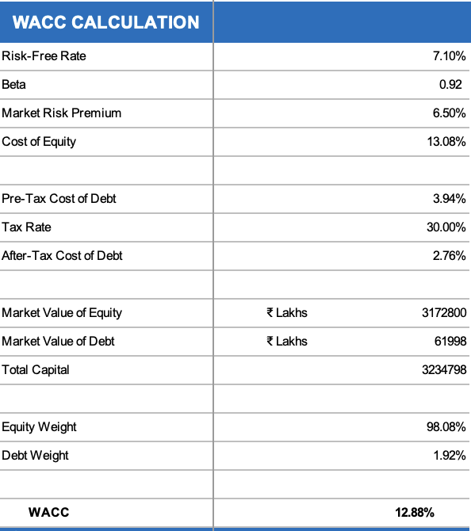

Figure 4: DCF Discount Rate Framework
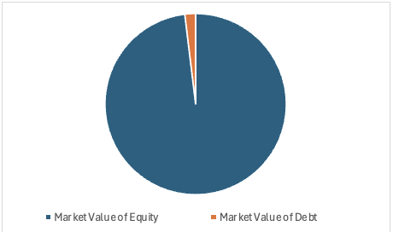
The WACC is a critical valuation input because it affects both the present value of forecast FCFF and the terminal value. Even relatively small changes in WACC can therefore produce meaningful changes in the resulting enterprise value.

Terminal Value
Terminal value represents the value of FCFF beyond the explicit FY2026E–FY2035E forecast period. In the model, the terminal value contributes approximately 64.8% of enterprise value, making the valuation particularly sensitive to the assumptions applied to the terminal period.
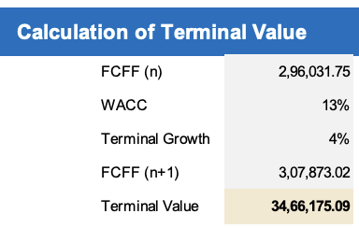

The model generates approximately ₹9,666 crore of present value from forecast-period FCFF and approximately ₹17,800 crore from the terminal value, resulting in an enterprise value of approximately ₹27,466 crore.
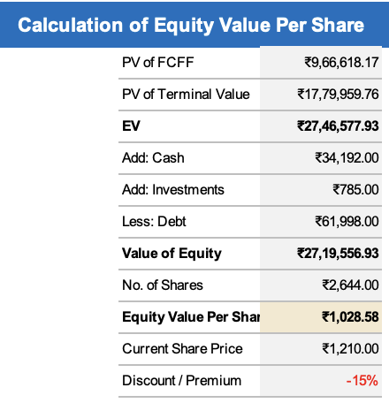
This composition is important when interpreting the DCF because the majority of value is derived from the company's expected long-term cash-generation capacity rather than the explicit ten-year forecast period.

The resulting equity value is approximately ₹27,19,556 Lakhs. Dividing this by 2644 Lakh shares gives an intrinsic value of ₹1,028.58 per share.

TRADING PEER MULTIPLES
The trading comparable analysis benchmarks United Breweries Limited against selected listed companies in the Indian alcoholic beverages industry using commonly applied valuation multiples. The comparison includes EV/Revenue, EV/EBITDA, EV/EBIT and P/E. UBL's multiples are compared with United Spirits, Radico Khaitan, Globus Spirits, Allied Blenders and Som Distilleries.

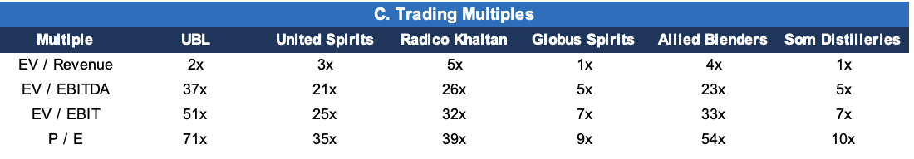
UBL trades at 2x EV/Revenue, which is below United Spirits, Radico Khaitan and Allied Blenders, but above Globus Spirits and Som Distilleries. However, on earnings-based multiples, UBL trades at 37x EV/EBITDA, 51x EV/EBIT and 71x P/E, representing relatively higher multiples within the peer set shown.
The difference between UBL's revenue multiple and its substantially higher earnings multiples reflects the relatively low operating margins embedded in the comparable figures. This makes the EV/EBITDA and P/E multiples particularly relevant when assessing how the market is valuing UBL's current earnings base versus its peers.
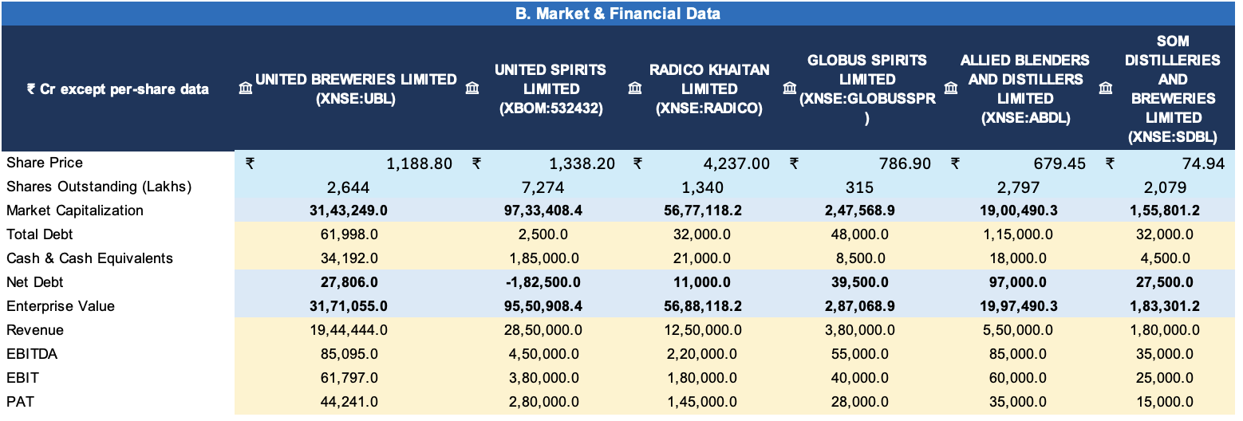
Key Takeaway--UBL's trading profile shows a relatively moderate EV/Revenue multiple but substantially higher earnings-based multiples, indicating that the company's current valuation is more demanding when measured against EBITDA, EBIT and earnings.
Summary
United Breweries Limited (UBL) is a major participant in the Indian beer industry, with its business focused primarily on the manufacture, purchase and sale of beer and non-alcoholic beverages. The company has continued to focus on volume growth, premiumisation, product innovation, distribution expansion and capacity addition. In FY2025, consolidated revenue stood at ₹19,40,854 lakh, while PAT was ₹44,241 lakh. The company reported approximately 6% volume growth during FY2025, with the premium segment approaching 32% of its portfolio.
Driver | Model Assumption / Outcome
FY2025 Revenue | ₹19,40,854 lakh
FY2035 Revenue | ₹34,75,001 lakh
Revenue CAGR | ~6.0%
FY2025 EBITDA Margin | 4.38%
FY2035 EBITDA Margin | 14.42%
FY2035 FCFF | ₹2,96,032 lakh
WACC | 12.8822%
PV of Forecast FCFF | ₹9,666 crore
PV of Terminal Value | ₹17,800 crore
Enterprise Value | ₹27,466 crore
Equity Value | ₹27,196 crore
DCF Value / Share | ₹1,028.58
Financially, UBL has shown a strong improvement in scale over FY2021–FY2025. Revenue increased from ₹10,18,576 lakh to ₹19,40,854 lakh, while PAT increased from ₹11,383 lakh to ₹44,241 lakh. Profitability, however, has remained sensitive to input costs, pricing and volume growth. FY2023 demonstrated this sensitivity, with strong volume growth but significant margin pressure from raw-material and packaging inflation. Profitability improved subsequently as operating conditions and pricing strengthened.

The DCF model assumes a gradual normalisation of revenue growth from 7.0% in FY2026E to 5.0% by FY2034E–FY2035E, resulting in approximately 6% revenue CAGR through FY2035E. The more significant assumption is the expansion in EBITDA margin from 4.38% in FY2025 to 14.42% in FY2035E. This drives EBITDA to approximately ₹5,01,092 lakh and FY2035E FCFF to ₹2,96,032 lakh. Consequently, long-term margin expansion is the most important operating assumption within the valuation.
The DCF uses a 12.8822% WACC and produces a ₹27,466 crore enterprise value and ₹27,196 crore equity value, resulting in an intrinsic value of ₹1,028.58 per share. The model's market-price input is ₹1,210 per share. Approximately 64.8% of enterprise value comes from the terminal value, making the valuation particularly sensitive to WACC, terminal growth and long-term operating margins.
The trading comparable analysis provides an additional market-based valuation perspective. UBL trades at 2x EV/Revenue, 37x EV/EBITDA, 51x EV/EBIT and 71x P/E in the supplied peer comparison. Compared with United Spirits, Radico Khaitan, Globus Spirits, Allied Blenders and Som Distilleries, UBL's revenue multiple is relatively moderate, while its earnings-based multiples are considerably higher. This highlights the importance of profitability and margin expectations in understanding UBL's valuation.
UBL's ownership structure is also concentrated. As of March 31, 2025, the Promoter & Promoter Group held 70.83%, including 61.52% held by foreign promoters and 9.31% by Indian promoters. FIIs held 6.91%, mutual funds 15.00% and individuals 2.48%.
Overall, the report indicates that UBL combines strong historical revenue growth, improving profitability, premiumisation and capacity expansion with a DCF that relies heavily on future margin expansion and terminal-period cash generation. The principal areas requiring attention are the sustainability of the assumed EBITDA margin expansion, the treatment of the announced ₹750 crore Uttar Pradesh brewery within forecast CAPEX, working-capital normalisation and the sensitivity of terminal value to WACC and terminal growth. These factors should be considered alongside the trading-comparable valuation when interpreting the overall valuation of UBL.

